**Topic**: Benchmark Assignment – Bible Verse Application

**Date**: 10/14/2018

**Revision**: 1.0

**Team**: Michael Weaver

|  |  |
| --- | --- |
| **User Story** | **Hours Worked** |
| Registration, Login, Project Setup | 1 |
| List View | 1 |
| Create Verse Page | 1 |
| Documentation | 1 |

|  |  |
| --- | --- |
| GitHub RUL | <https://github.com/battousairurik/BibleVerseCollector> |

**Technical Approach**

Views

* Account Views (Confirm-Email, Forgot-Password, Login, Register, etc.)
* Bible Verse Views (Create, Index)
* Manage Views (Add-Phone-Number, Change-Password, Index, Manage-Logins, etc.)
* Shared Views (_Layout, _Login-Partial)

Controllers

* Account Controller
* Bible Verse Controller
* Home Controller
* Manage Controller

Models

* Account View Model
* Bible Verse
* Identity Model
* Manage View Model

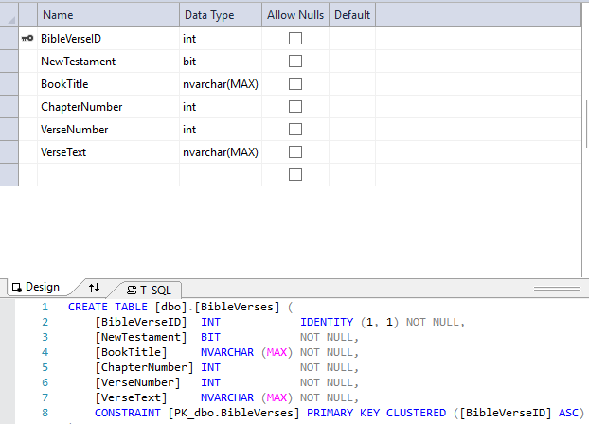

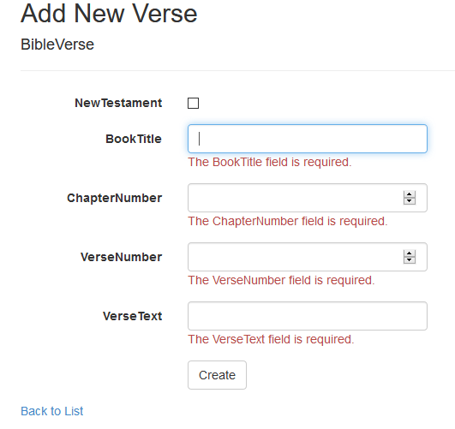

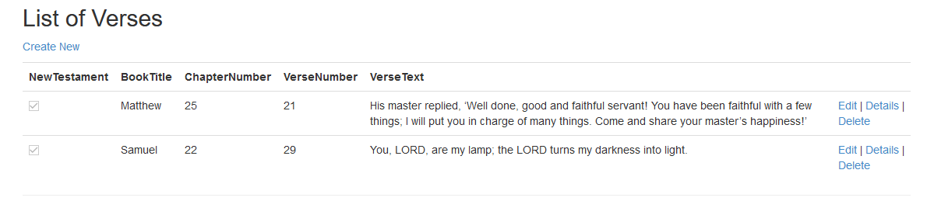

**Technical Explanation**

The home page of the application could be designed to randomly select any bible verse in its database to display as the home page, creating a bible verse of the day feel. A more complex algorithm could then prevent copies of a verse from appearing for a set amount of time. For an external use of the app, it can send the bible verse of the day to each users registered email, and mobile number if it is listed. For these features to be supported you would need

* Registered users
* Bible verse database
* Algorithm to handle verse selection and distribution